1. Go to MM01

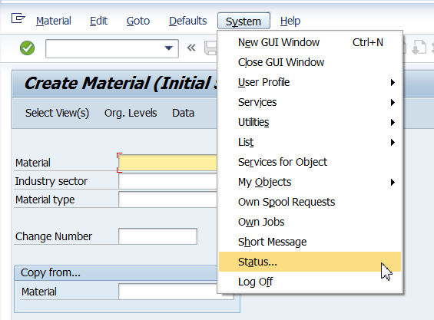

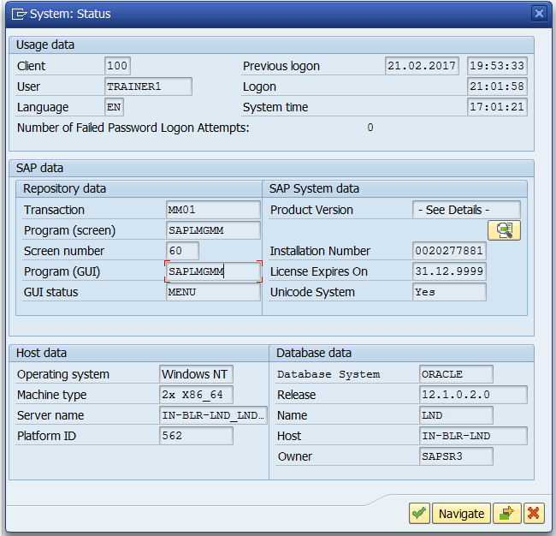

Double click on program name. In SE38, Go to Attributes, get the package name.

It is MGA.

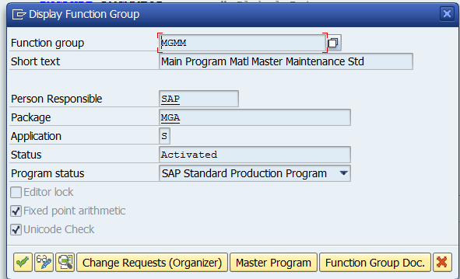

1. SE18

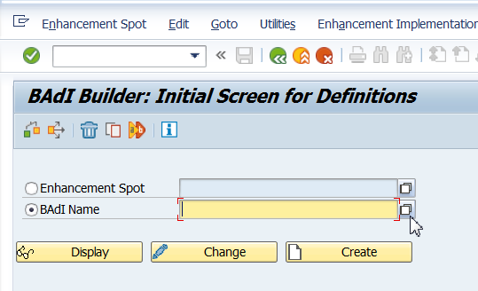

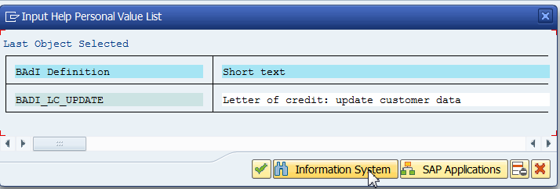

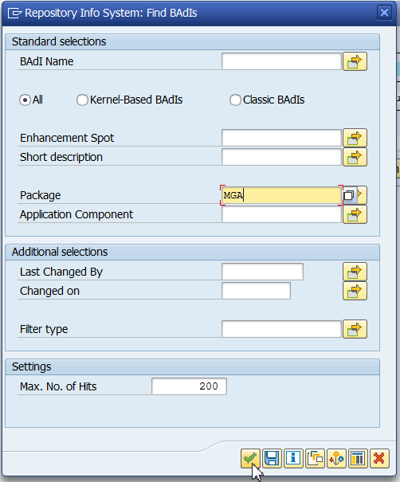

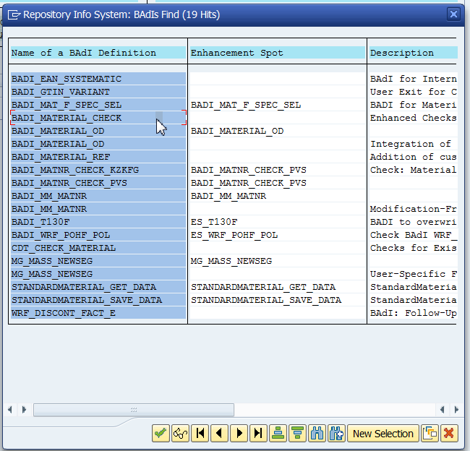

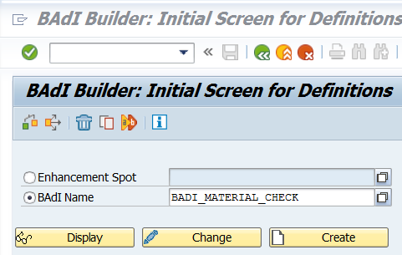

Copy BAdI definition name.

1. SE19

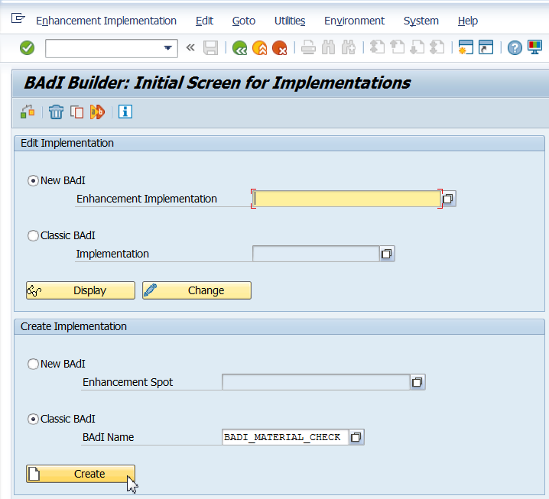

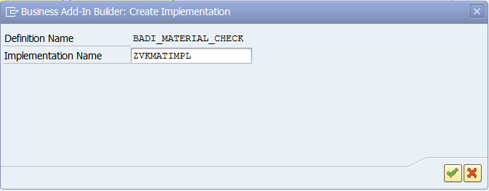

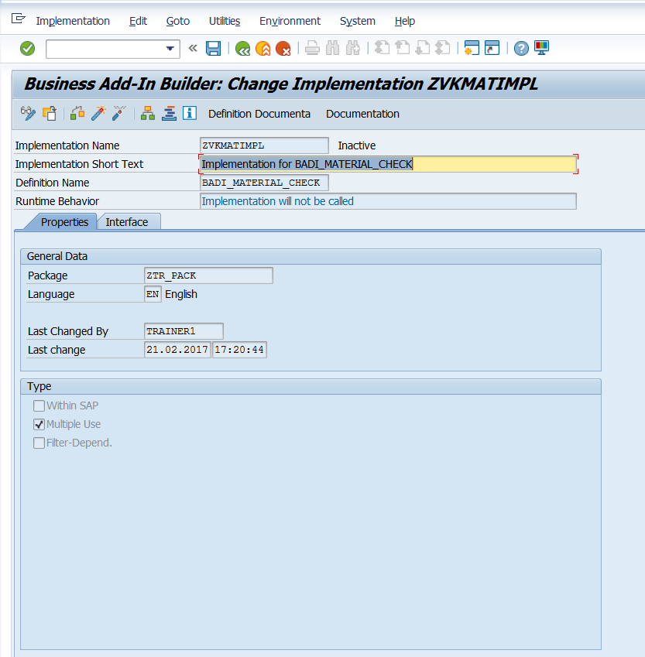

Double click on check data.

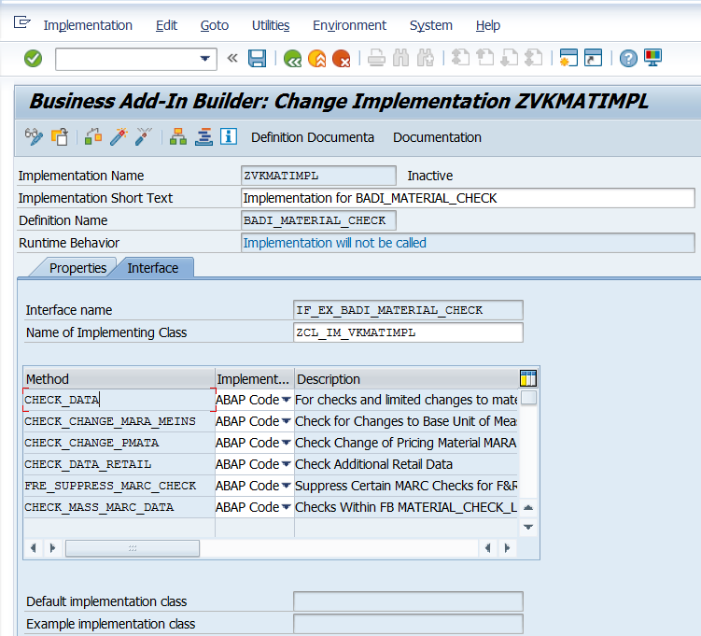

Double click on Check data below.

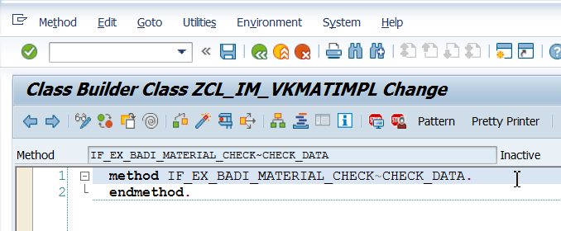

Click on parameters.

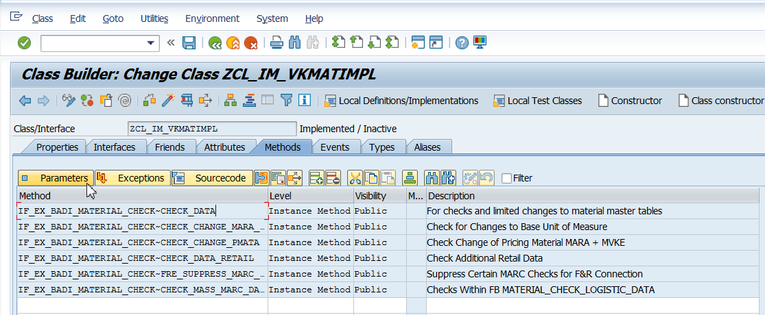

Double click on MARA(Associated Type).

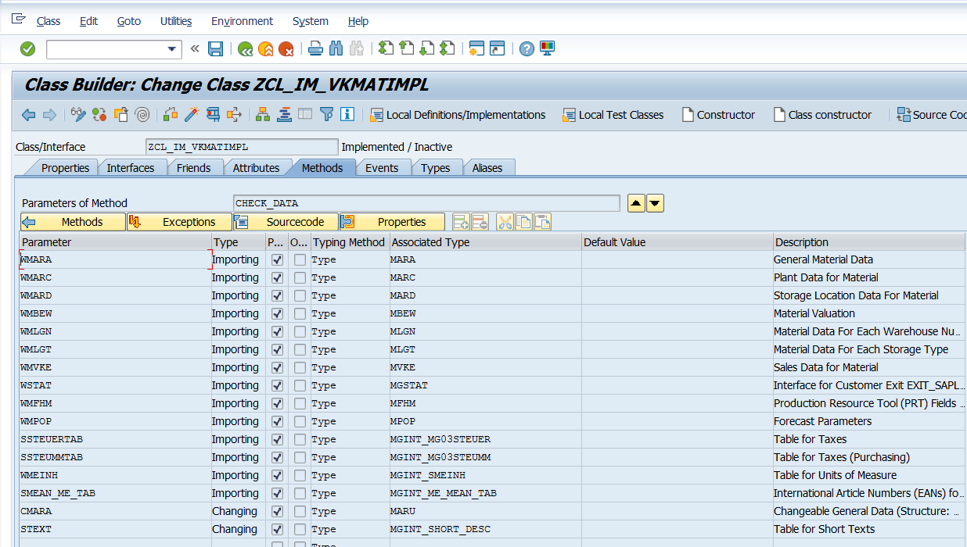

Observe fields of MARA Table.

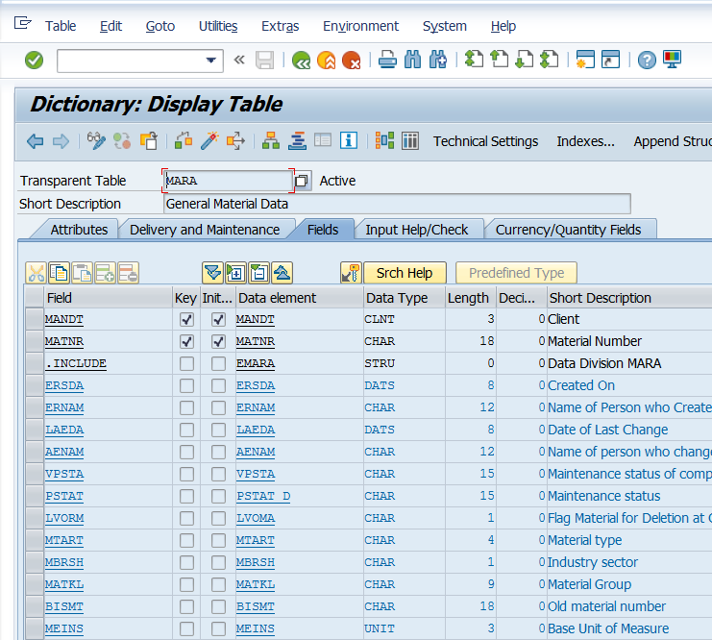

Go back till the time you come to the screen below. Write the method.

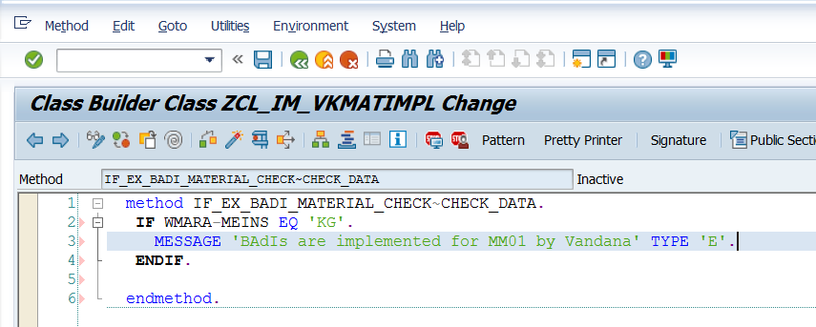

IF WMARA-MEINS EQ 'KG'.  
     MESSAGE 'BAdIs are implemented for MM01 by Vandana' TYPE 'E'.  
ENDIF.

Save, Activate, Go Back.

Execute MM01.

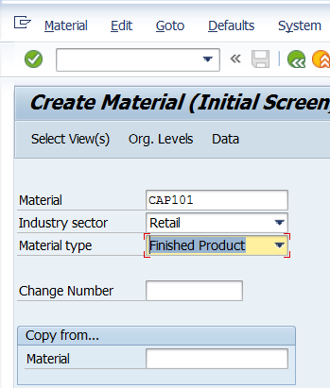

Press Enter on screen above.

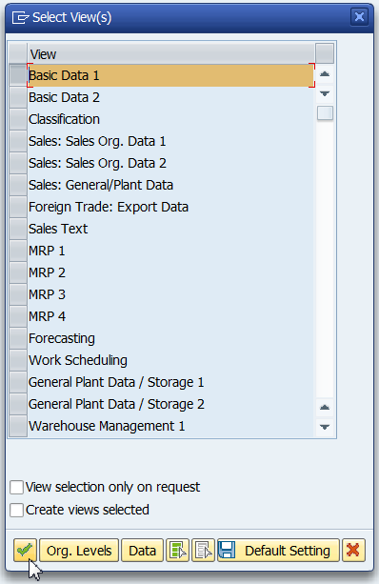

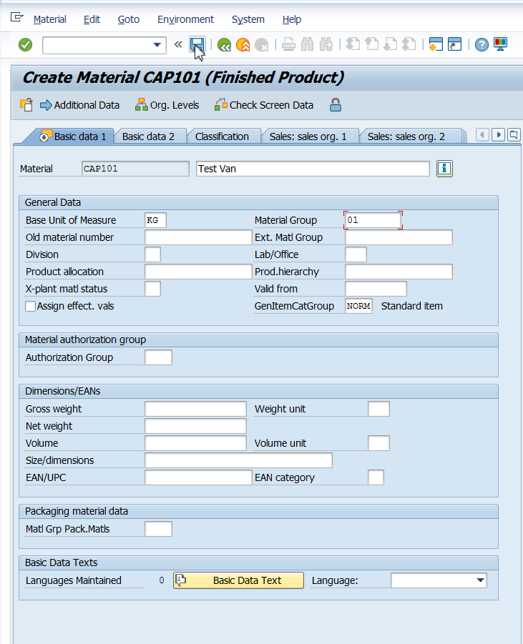

Save. See Error message.

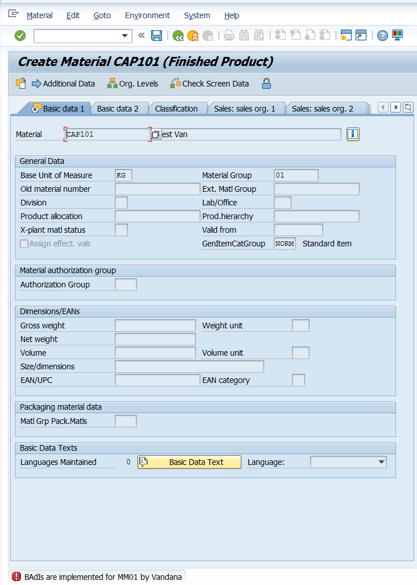

There can be multiple implementations of BAdIs. Deactivate the BAdI. Else everyone will see the same error.

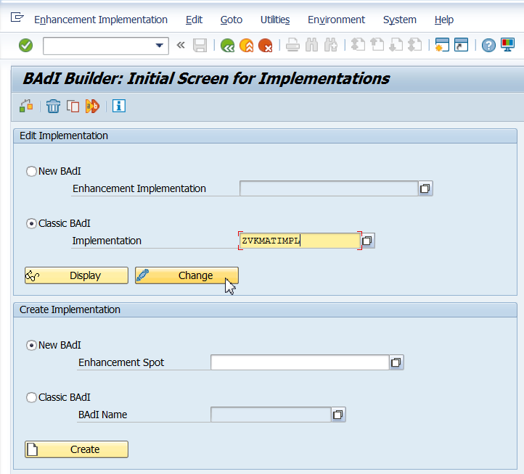

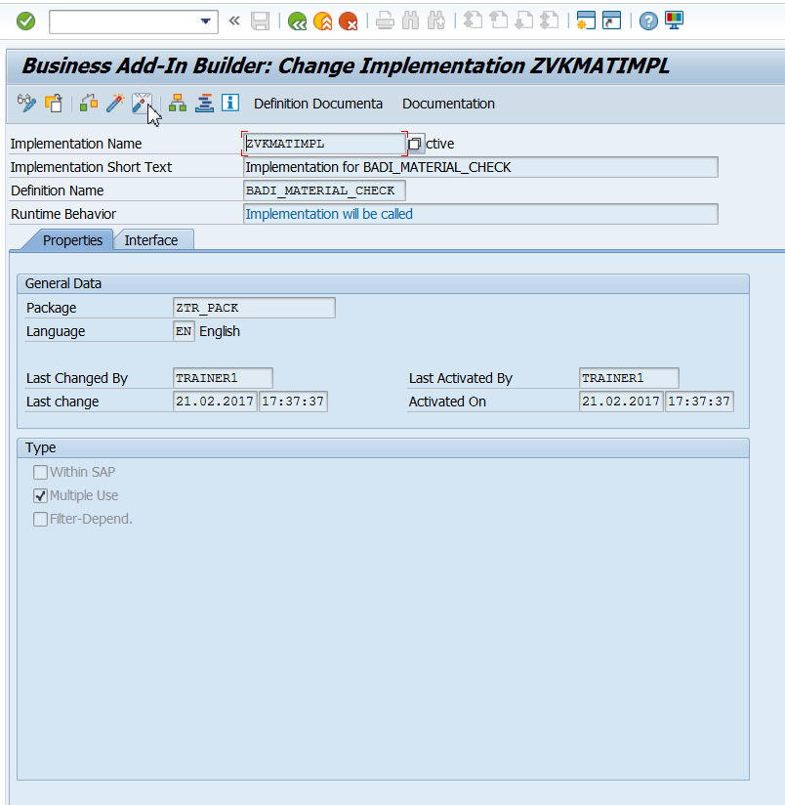

Observe status bar.

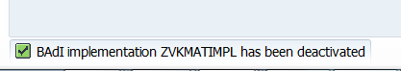

Not just deactivate, delete it at the main page of SE19.

Go to MM01 and observe no Error for KGs.

Similarly, BAdI implementation for transaction XD01 may be tried out.